The artifact that I made enhancements on was my Inventory management application that I created for my CS 360 Mobile Architect & Programming course that I completed in June 2025. The purpose of the application was to provide a way for warehouse associates to manage and track the warehouse’s inventory. I used this artifact for all three categories; I rebuilt my entire application to be operational and flawless. In general, I chose this artifact because it was the only course that I didn’t deliver a functional program, so I wanted to prove to myself that I can complete and improve the app. Now that I have completed all three enhancements, I can now deliver a functional program, with added improvements. I chose this artifact to include in my ePortfolio because of the current job market and to showcase my programming skills using the language Java. I have seen plenty of openings that are looking for developers that are proficient in Java and openings for android development as well. Another reason that I mentioned in the previous two narratives is that I selected this artifact because majority of consumers own a type of cellular device that can download and utilize apps and the mobile app market is one of the biggest markets and will keep on increasing. Even in the workforce, cell phones are being used as work devices for employees to complete their tasks. In tech, I believe it’s necessary to stay with and ahead of tech consumerism along with new software implementation. This is why I chose to update my application with Room database instead of using the standard SQL.
With implementing the Room database, I was able to showcase my skills on how to create a database, integrating it with data structures and initializing it to make it operational. For the initial application, I created a database, but I didn’t know how to implement it for mobile applications. After taking a prerequisite course for CS-360, I learned how to implement SQL database for a basic android application. For my enhanced application, I improved my initial database by using Room Database instead. This database gave me the ability to use annotations to create the database and to call the CRUD operations. I am also able to see live updates in the database as well. I made my program a little more organized by adding a database package to hold my Data Access Objects and Database. Room can integrate better with android platforms than SQL which improves the application overall. I believe I met the course outcome that I planned to meet in Module one. The only updates I plan on making are for the UI overall for the application to be ready for final submission.
I learned a lot when I created my Room database for my application and as I was improving the application overall. I learned what Room database was and how to implement it. I learned how to use annotations outside of JUnit testing. I knew how to integrate an array data structure with an SQL database, so I had to learn how to integrate Room with a HashMap structure. I learned how to create background threads to have a database running behind the scenes. I had a refresher on how to use Logcat, which helped me remedy any bugs I needed. I also learned how to use the Database Inspector to track that the items were being saved to database.
Insert into Database:
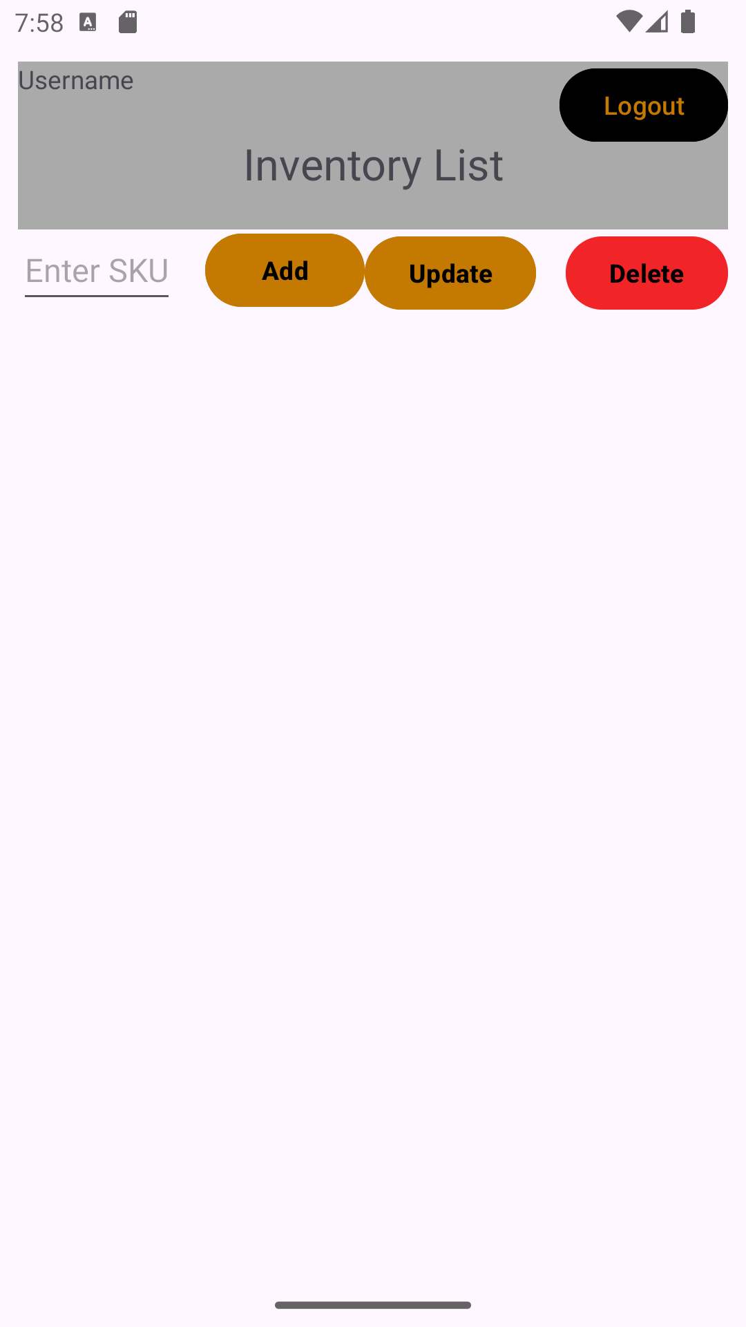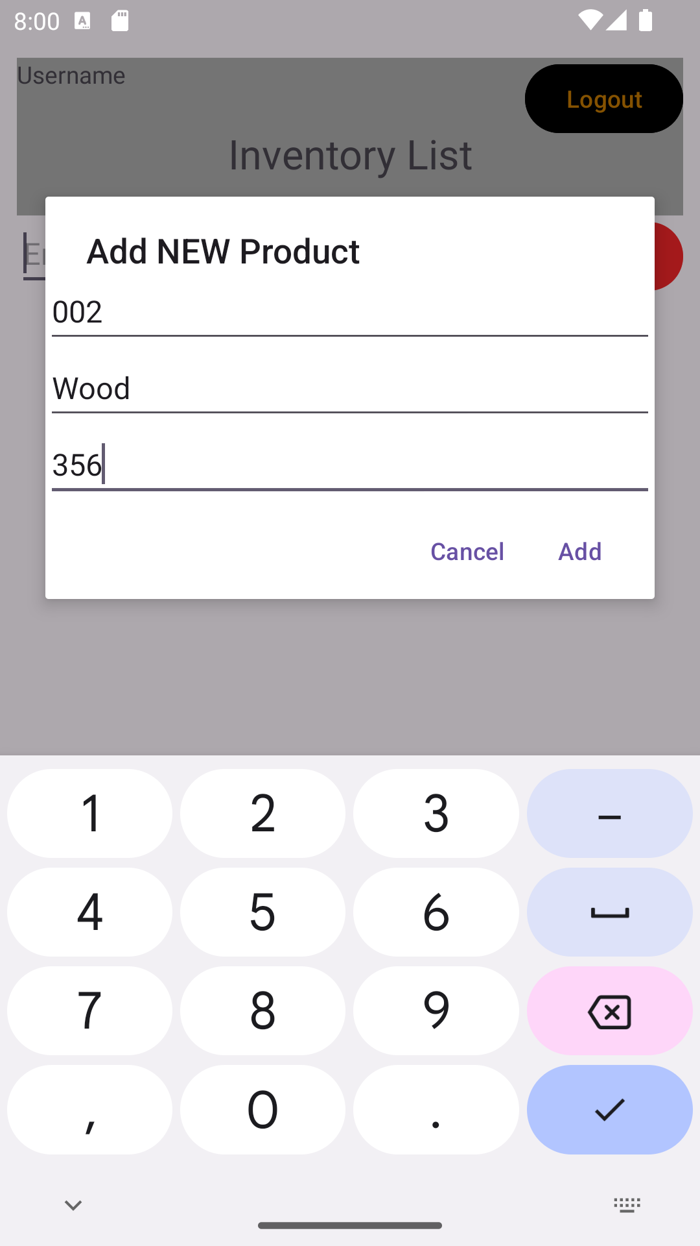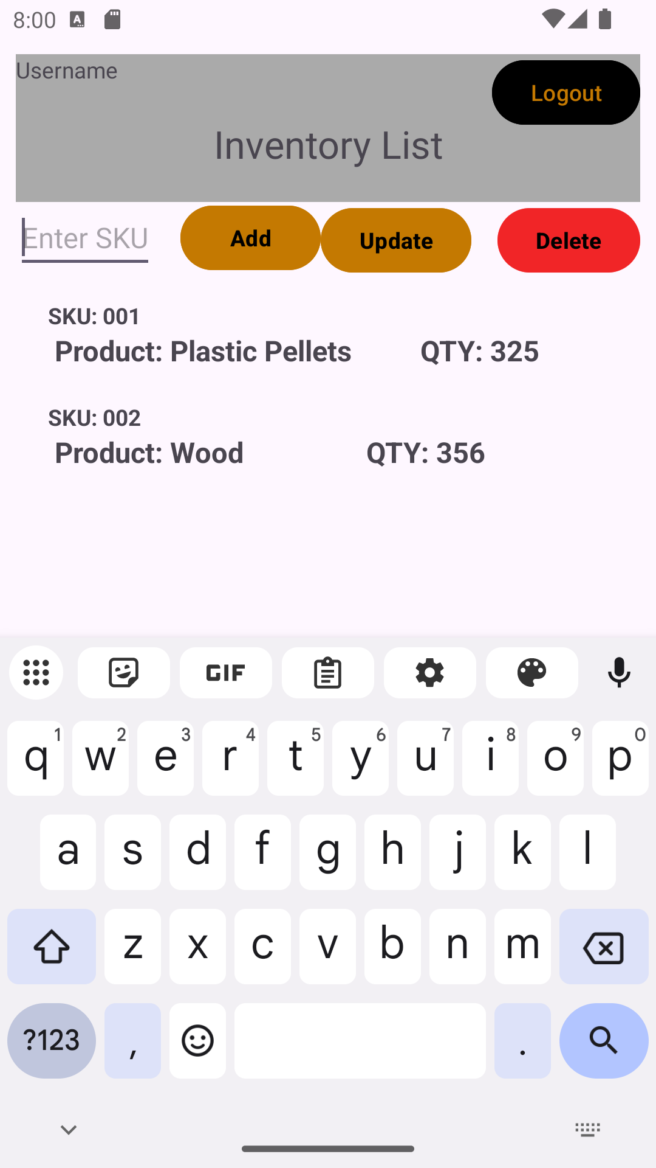
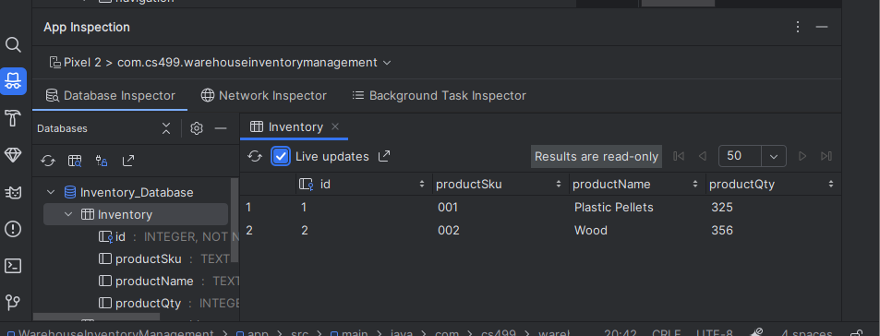

Update to the Database:
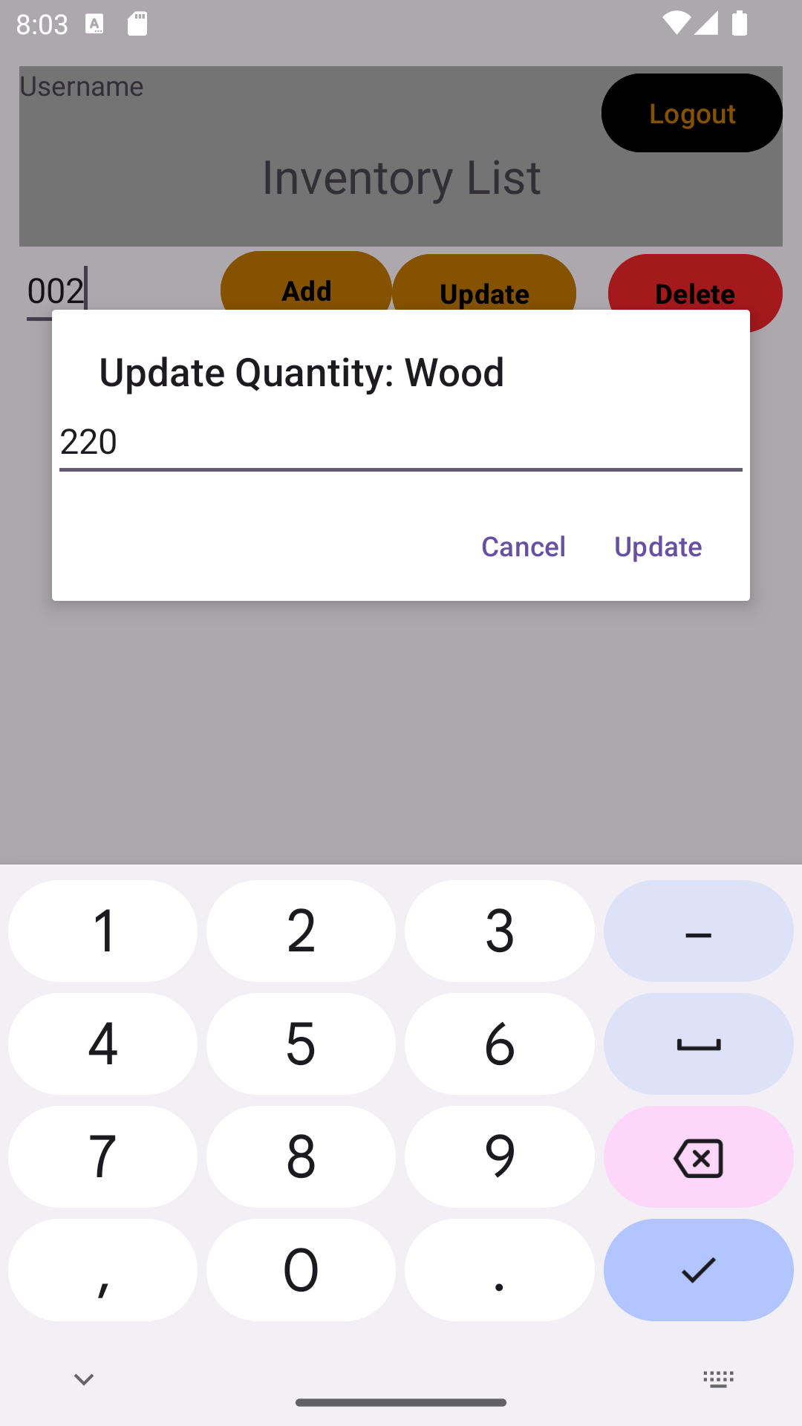
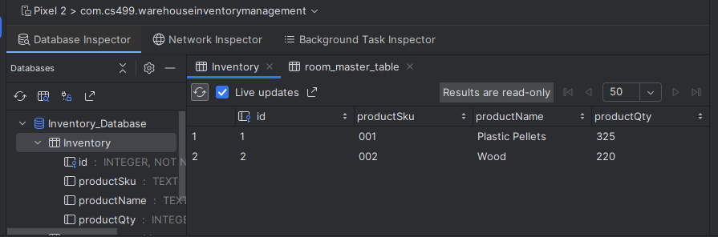

Delete From Database:

